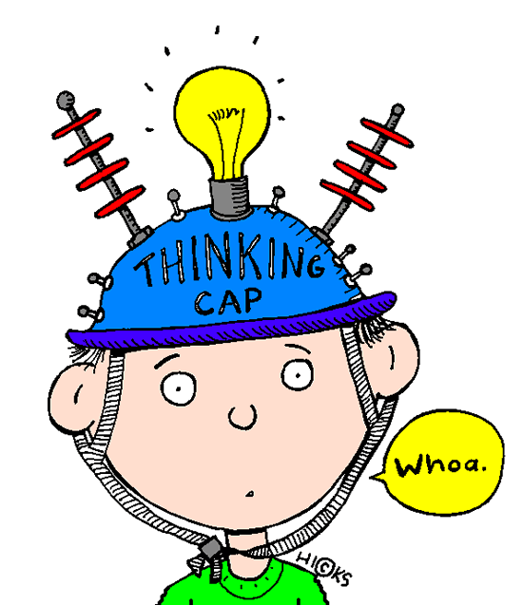SPH3U **Note: Introduction to Electric Circuits**  Date:____________

What do you remember? Match the terms below with the correct definition:

|  |  |
| --- | --- |
| **Term** | **Definition** |
| ____current | A. Circuit in which elements are connected in line so  there is only one path for charges to follow. |
| ____voltage | B. Opposition to the flow of charge. |
| ____load | C. Device which measures electric potential difference. |
| ____switch | D. The work per unit charge required to move a positive  charge between two points in an electric circuit. |
| ____voltmeter | E. Control device in an electric circuit. |
| ____ammeter | F. The rate at which electrical charges flow in a circuit. |
| ____series circuit | G. Circuit in there is more than one path for charges to  follow. |
| ____parallel circuit | H. A direct pathway with low resistance connecting two  sides of a battery or other electrical source. |
| ____resistance | I. Device which converts electrical energy into other  forms of energy. |
| ____short circuit | J. Device which measures electric current. |
| ____source | K. Device which supplies energy to charges in a circuit. |

**Three key components of an electric circuit:**

Source:

Load:

Conductor:

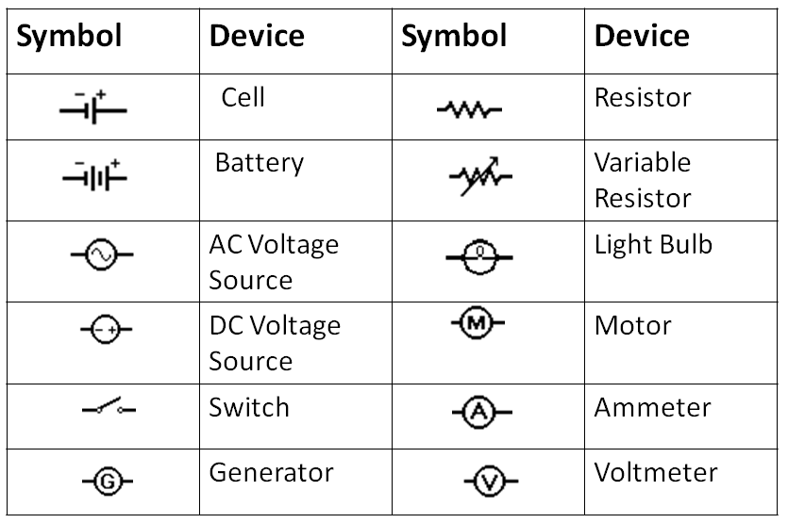**Circuit Symbols** :

**Draw the circuit below and indicate the direction that positive charge (conventional current) would flow:**

**+**

**-**

**-**

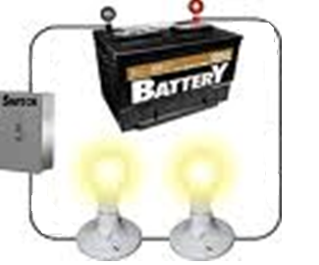

**Direction of Current Flow:**

**Conventional Current:**

**Electron Flow:**

**Diagram:**

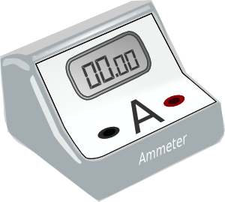**Circuit Measurements**

In the diagram below, add an ammeter measuring conventional current flowing from the cell and a voltmeter measuring voltage across the light bulb:

**Current:**

* **Measured with an ______________________**

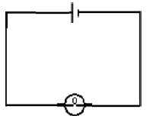 • connected *in line* ( in __________ ) so that current passes directly

through the meter.

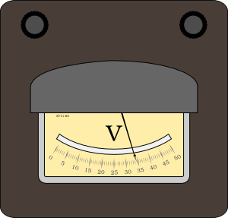

**Voltage:**

* **Measured with a _______________**
* **connected *across* the device ( in _______________)**

**Types of Current**

Direct current (DC):

Alternating Current (AC):

**Circuit Parameters**

**Current:**

**Potential Difference or Voltage (V)**

We can compare an electric circuit to a water circuit to understand the concept of potential difference and how a battery works:

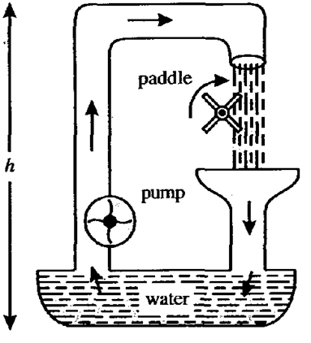

Definition:

Analogy:

**Potential Gain vs. Potential Drop**

Battery: Potential ____________

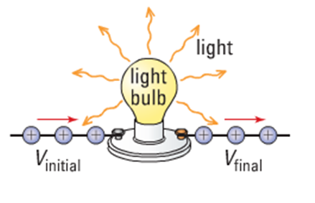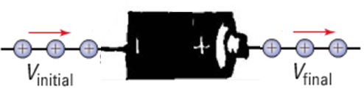

Bulb: Potential ____________

Identify each item below as producing a VOLTAGE GAIN (+ΔV) or VOLTAGE DROP (-ΔV)

|  |  |
| --- | --- |
| Item | ***VOLTAGE GAIN or VOLTAGE DROP*** |
| Battery |  |
| Motor |  |
| Light Bulb |  |
| Resistor |  |
| Power supply |  |